Report presentation of packet sniffer tool:
Introduction:
We created a simple tool (a packet sniffer) using Python to listen in on our computer's network connection (Wi-Fi) and look at the data being sent and received.
The main goal was to see how computers talk on the internet by capturing small pieces of information called packets.The tool was designed to capture, dissect, and analyze network traffic in real-time, focusing on key parameters like Source/Destination IPs, Protocols, and Port numbers.
Key Tools Used:
Tool | Why We Used It | Simple Explanation
Python | The programming language. | The instructions we wrote for the computer.
Scapy | The main library (add-on). | A special toolkit that lets Python capture and read network packets.
Venv (Virtual Environment) | Project isolation. | A clean box for our project to make sure the Scapy tool doesn't break other Python projects.
Admin Rights | Necessary permission. | The tool needs special permission (like running as Administrator) to talk directly to the Wi-Fi card.
BPF Filters | Focusing the capture. | Simple rules (like "tcp port 443") to ignore noise and capture only the traffic we want to study.

How the Tool Works
Our main code (sniffer.py) tells Scapy to do two things for every packet captured:
- Read the Headers: It identifies the addresses and ports: Source IP (who sent it), Destination IP (where it's going), and the Protocol (TCP, UDP, etc.).
- Show the Data (Payload): It prints the information that the packet is carrying.
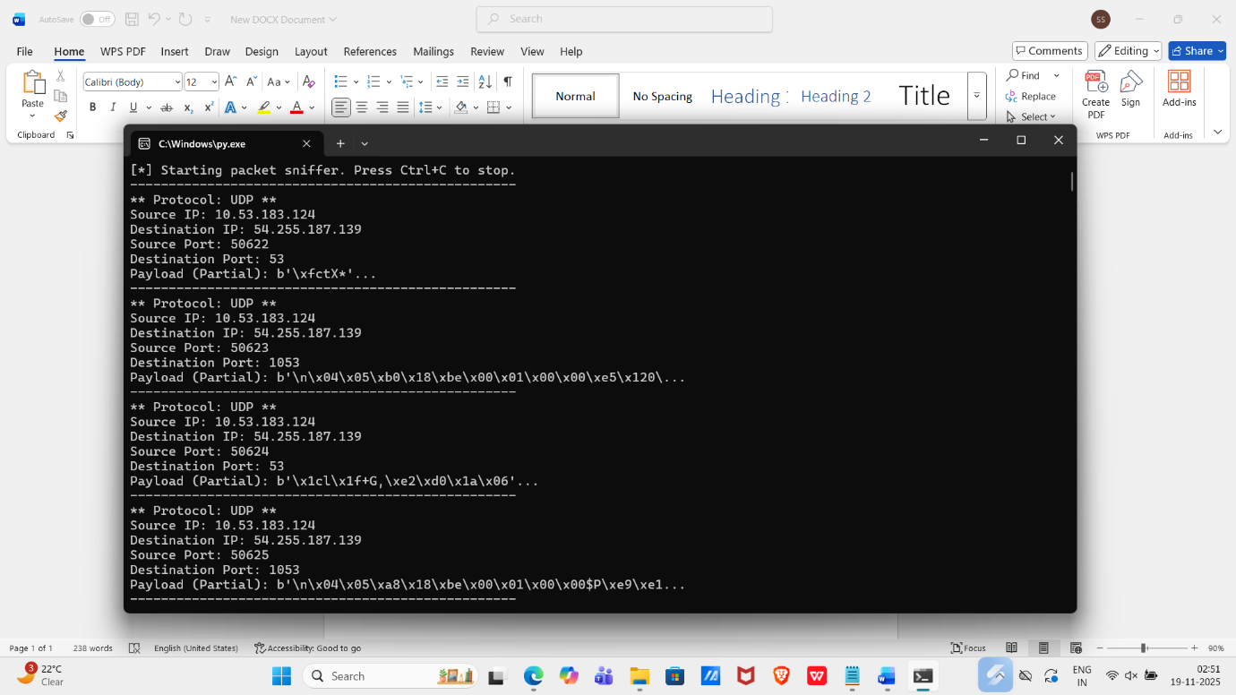

4.Data Saving Feature
We successfully updated the tool to save all the captured information into a file called captured_data.pcap when the user presses Ctrl + C. This standardized file format allows the data to be opened in professional tools like Wireshark for advanced, visual analysis.

5. Conclusion
This project confirms that network traffic can be easily monitored and read by anyone on the same network. We learned the importance of security protocols like HTTPS because it protects the privacy of data (passwords, messages) by making it unreadable to sniffer tools.

